Welcome to the MEDEV meeting 19-20 June 2023 in Stockholm

TLV, the Swedish Dental and Pharmaceutical Benefits Agency, welcomes you to Stockholm for the MEDEV meeting 19-20 June 2023.

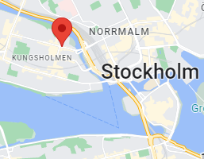
Meeting venue
Tandvårds- och Läkemedelsförmånsverket
Fleminggatan 14
112 26 Stockholm

Contacts at TLV

Contact persons at TLV is Carl Björvang and Johan Pontén. Please feel welcome to address any questions to
carl.bjorvang@tlv.se, +46-8 -5800 73 51
johan.ponten@tlv.se, +46-8 -5800 75 03.

Welcome to Stockholm!

Practical details

Accommodation

TLV does not cover travel cost or accommodation. However, we have arranged for discounted rates at two nearby hotels, subject to availability. To avail of these rates, please contact the hotel of your choice at the contact details below and provide the discount code during the booking procedure:

- Scandic Grand Central
Kungsgatan 70
111 20 Stockholm, Sweden
Tel: +46 8 512 520 00
Email: grandcentral@scandichotels.com
https://www.scandichotels.se/hotell/sverige/stockholm/scandic-grand-central
Discount Code: PRO10SE

- Hotel C Stockholm
Vasaplan 4
111 20 Stockholm, Sweden
Tel: +46 8 50 56 31 00
Email: reservations@hotelcstockholm.se
https://hotelcstockholm.se/
Discount Code: NHRCORP

There is also a nearby hostel. Prices vary from SEK 240 in a 12-bed dormitory, to SEK 495 for a single room.

- City Hostel (SEK 240-495)
Fleminggatan 19
112 26 Stockholm, Sweden
Tel: +46 841 003 830
Email: info@cityhostel.se
http://www.cityhostel.se/en/

Getting from Stockholm Arlanda Airport to Stockholm city

There are different options to get from the airport to the city.

- Arlanda Express
An express train to Stockholm Central Station takes approximately 20 minutes. A single ticket costs SEK 320, return tickets SEK 600. There are discounted tickets for two or more persons travelling together, or when buying tickets in advance online. Discounted tickets cannot be rebooked or refunded.
https://www.arlandaexpress.com/
- Flygbussarna (bus)
Buses to Cityterminalen in central Stockholm (connected to the Central Station), takes approximately 45 minutes. A single ticket costs SEK 129, return ticket SEK 209. https://www.flygbussarna.se/en
- Public transportation (commuting train)
Commuting train to Stockholm Central Station, takes approximately 38 minutes. A single journey ticket, including passage supplement fee, costs SEK 169. If you plan to further use public transportation during your stay, you may want to buy a Travelcard (loaded on an SL Smart card). More information under “Getting around” below.
- Taxi
Taxi prices are not regulated in Sweden, and there has unfortunately been some “creative” pricing. Hence, we recommend you use one of the major taxi companies, Taxi Stockholm, Taxi Kurir or Taxi 020. They have fixed prices for trips to and from Stockholm Arlanda Airport, varying from SEK 700 to SEK 850. Always ask the driver beforehand.

Getting around with public transportation
You can buy single tickets either via the SL App ‘SL-Reseplanerare och biljetter’, by tapping your credit card or from manned ticket booths. If you intend to travel extensively throughout Stockholm, it might be better to get a travelcard. You can load these either onto the SL App or on a SL Smart card, which can be bought from manned ticket booths for SEK 20.
- 24-hours travelcard
Valid 24 hours from the first time of use. Costs SEK 165.
- 72-hours travelcard
Valid 72 hours from the first time of use. Costs SEK 330.
- 7-day travelcard
Valid from 00:00 on the first day of travel, until 04:30 on the day after the travelcard expires. The 7-day travelcard is only available with an SL Access card. Costs SEK 430.
https://sl.se/en/in-english/fares--tickets/
If you wish to extend your stay

A few suggestions of popular attractions in Stockholm
- The Stockholm City Hall
This is one of Sweden’s most famous buildings, where the Nobel Prize Banquet is held. It’s within walking distance from the meeting venue. Admission to guided tours is SEK 140.
http://international.stockholm.se/the-city-hall/
- The Nobel Museum
The Nobel Museum is located in the former Stock Exchange Building, in the Old town in central Stockholm. Here you can learn more about the Nobel Prize and its founder, as well as the Nobel Laureates and their endeavours. Admission is SEK 140. An audio-guided tour is included in the admission fee.
https://nobelprizemuseum.se/en/
- The Royal Palace
Located in Old town, it is one of Stockholm’s main tourist attractions. A castle was first built here in the middle of the 13th century. However, most of it was destroyed in a fire in 1697. The castle we see here today was taken into use in 1754, when king Adolf Frederick and his spouse Louisa Ulrika moved in. Entrance fee to the Royal Palace is SEK 170. The Royal Armoury, housed in the cellar vaults of the Royal Palace, has free admission on Thursdays, with a SEK 150 entrance fee on other days.
The changing of the Royal Guard (Mondays–Saturdays at 12:15, Sundays and holidays at 13:15) at the outer courtyard, is also popular.
https://www.kungligaslotten.se/english/royal-palaces-and-sites/the-royal-palace
http://livrustkammaren.se/en
http://www.stockholmgamlastan.se/se-gora/evenemang/vaktavlosningen.php
- The Vasa Museum
Sweden’s own Titanic … The Vasa Ship capsized on its virgin tour in 1628. It spent 333 years on the seabed before it was salvaged, and it is the only preserved 17th century ship. The Vasa Museum, located on the island of Djurgården, is the most visited museum in Scandinavia. Admission is SEK 170. Guided tours are included.
http://www.vasamuseet.se/en

- The ABBA Museum
What would it be like to be the fifth member of ABBA? At the ABBA Museum, located on the island Djurgården, you can sing at the Polar Studio and find out what you would look like in their stage costumes. Your material will be saved on your personal ID on your ticket. Admission is SEK 260-290 depending on time, payable online or by card at the venue. Audio guide is SEK 20. The ticket price also includes entrance to the Swedish Music Hall of Fame, and the History of Swedish Popular Music.
http://www.abbathemuseum.com/en
- Skansen
If the weather is nice, a trip to Skansen, on Djurgården, is recommended. Skansen is the world’s oldest open-air museum. Here you can see traditional homes from different parts of Sweden, as well as meet both domestic and wild nordic animals. Admission is SEK 160.
http://www.skansen.se/en/kategori/english

Swedish glossary

Greetings & courtesies
Swedish | English
God morgon | Good morning
God natt | Good night
Hej  or Tjena | Hello  Hi (informal)
Hej då | Bye-bye
Hur mår du?  or Hur står det till?  or Hur är läget? | How are you? (neutral)  How are you? (formal)  What’s up? (informal)
Bara bra, tack. Och du? | I’m fine, thanks. And you?
Tack | Thank you/Please (depending on the context)
Varsågod | Here you go/Please/You’re welcome (depending on the context)
Talar du engelska? | Do you speak English?
Trevligt att träffas | Pleased to meet you
Ursäkta mig | Excuse me
Ursäkta mig, var ligger toaletten? | Excuse me, where is the restroom/toilet?

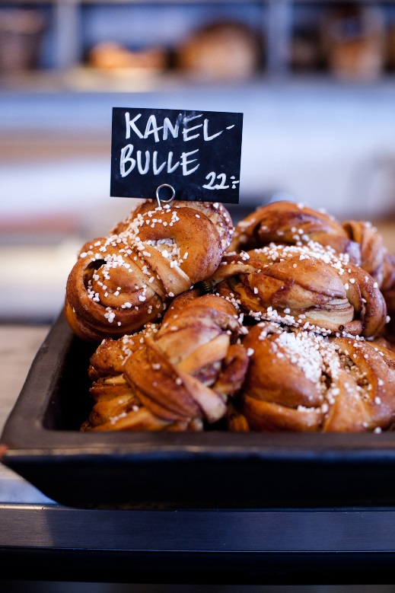

Food & drinks
Swedish | English
Bröd | Bread
En dagens, tack | Today’s special, please (mostly lunch time)
En stor stark | A lager beer (literally: ‘a big strong’)
Ett glas rött/vitt | A glass of red/white wine
Fisk | Fish
Kaffe på maten | Coffee after the meal (literally: ‘coffee on the food’)
Knäckebröd | Crispbread
Kyckling | Chicken
Kött | Meat
Köttbullar och lingonsylt | Meatballs and lingonberry jam
Lättöl | Low-alcohol beer (a maximum of 2.25% alcohol by volume, common in Sweden)
Mjölk | Milk
Ost | Cheese
Skaldjur | Shellfish
Smör | Butter
Vatten | Water
Vegetariskt  Vegansk | Vegetarian  Vegan

Feelings
Swedish | English
Förlåt | I’m sorry/Forgive me
Jag gillar dig | I like you
Jag hatar dig | I hate you
Jag älskar dig | I love you
Jag är ledsen | I’m sorry/I’m sad (depending on the context)

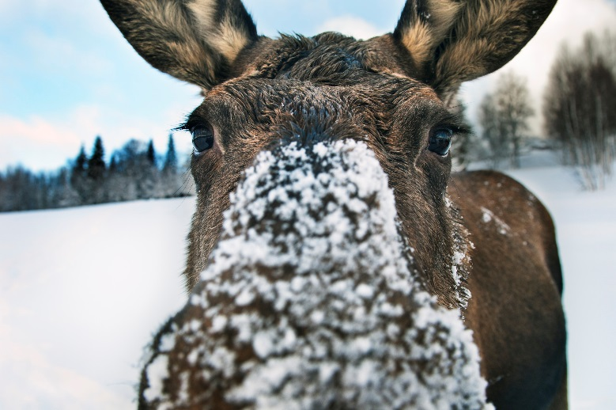

Typically Swedish
Swedish | English
Fika | Coffee break (including the socialising that goes with it)
Glögg | The Swedish version of mulled wine
Lagom | Just right; not too little, not too much
Nja (nej + ja) | No and yes
Ombudsman | Ombudsman (!)
Påtår | A refill of coffee (often included)
Sambo | Someone who lives together with his/her partner without being married (short for samboende)
Smörgåsbord | Smorgasbord
Särbo | Someone who is in a long-term relationship but does not live together with his/her partner
Älg | Moose (Eurasian elk)

Numerals
Swedish | English
0 | Noll
1 | Ett
2 | Två
3 | Tre
4 | Fyra
5 | Fem
6 | Sex
7 | Sju
8 | Åtta
9 | Nio
10 | Tio
Source: https://sweden.se/

